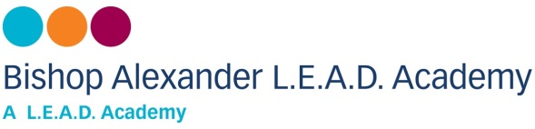

**UNIFORM ORDER FORM**

Name of child …………………………………… Class ………………………………………

***Sweatshirt with school logo***

Children’s size: 4-5yrs, 5-6yrs, 6-7yrs, 7-8yrs, 9-10yrs, 11-12yrs - **£10.50**

Adult sizes: XS, S, M, L, XL - **£15.00**

***Cardigan with school logo***

Children’s size: 4-5yrs, 5-6yrs, 6-7yrs, 7-8yrs, 9-10yrs, 11-12yrs - **£12.00**

Adult size: XS, S, M, L, XL - **£15.50**

***PE Kits (White t-shirt, Black shorts and Black PE Bag)***

Children’s size: 3-4yrs, 5-6yrs, 7-8yrs, 9-10yrs, 11-13yrs **£15.00**

***PE T-Shirt*** 3-4yrs, 5-6yrs, 7-8yrs, 9-10yrs, 11-12yrs, 13yrs - **£6.00**

***PE Shorts*** 3-4yrs, 5-6yrs, 7-8yrs, 9-10yrs, 11-12yrs, 13yrs - **£6.00**

***Fleece Jackets***

Children’s size: 3-4yrs, 5-6yrs, 7-8yrs, 9-10yrs, 11-13yrs - **£14.00**

Adult size: S, M, L, XL - **£20.00**

***Waterproof Jacket***

Children’s size: 3-4yrs, 5-6yrs, 7-8yrs, 9-10yrs, 11-12yrs, 13yrs - **£21.00**

Adult size: S, M, L, XL - **£25.00**

***Book Bags* - £8.50**

**To place a uniform order, please go onto the School Gateway app and pay for your items, then email Mrs Hade on** [**sallyh28@bishopalexanderacademy.co.uk**](mailto:sallyh28@bishopalexanderacademy.co.uk) **with the sizes you wish to purchase.**